Week 1 – 0

---coding-C-language features-optional. REG NO.:240901086

NAME : RENUGADEVI S

Q1) This is a simple challenge to help you practice printing to stdout. We're starting out by printing the most famous computing phrase of all time! In the editor below, use either printf or cout to print the string Hello, World! to stdout. Input Format You do not need to read any input in this challenge. Output Format Print Hello, World! to stdout. Sample Output Hello, World! Answer: (penalty regime: 0 %)

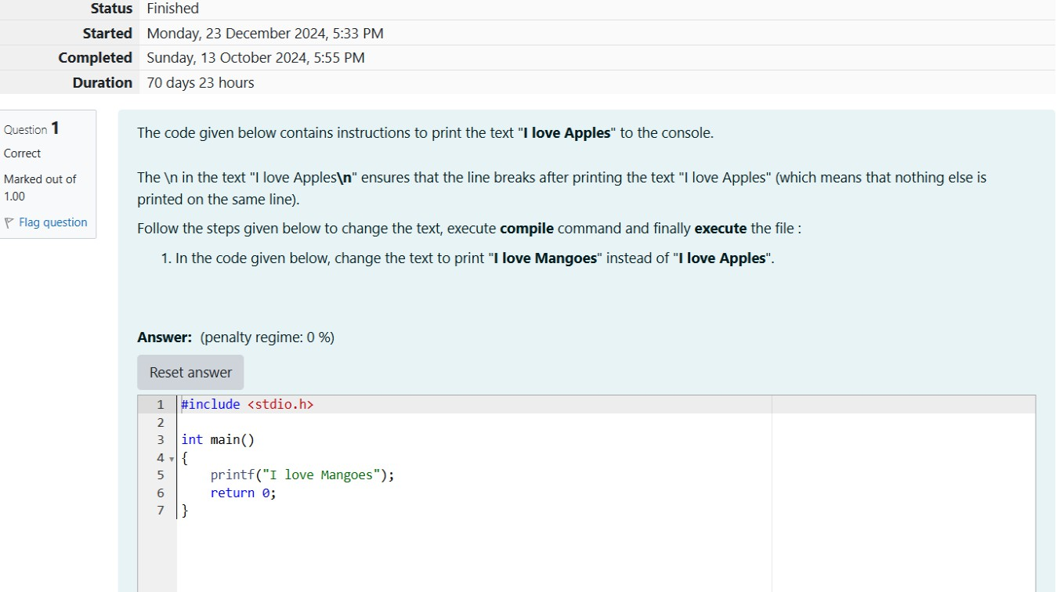

OUTPUT

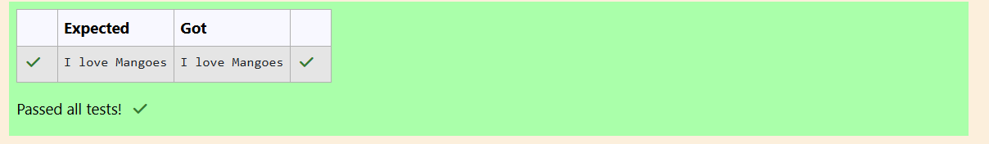

WEEK 1-0

CODING C LANGUAGE FEATURES OPTIONAL REG NO.:240901086

NAME: RENUGADEVI S

Q1) This is a simple challenge to help you practice printing to stdout. We're starting out by printing the most famous computing phrase of all time! In the editor below, use either printf or cout to print the string Hello, World! to stdout. Input Format You do not need to read any input in this challenge. Output Format Print Hello, World! to stdout. Sample Output Hello, World! Answer: (penalty regime: 0 %)

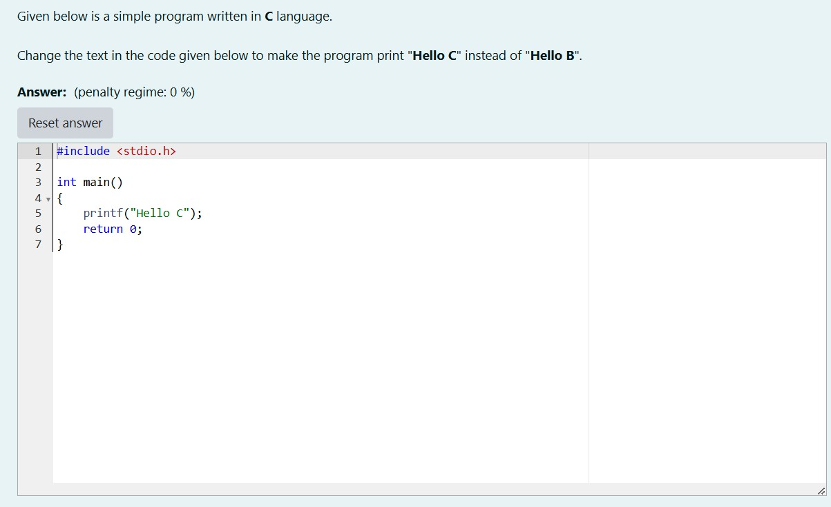

OUTPUT

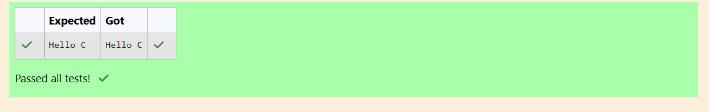

WEEK 01-01-PRACTICE SESSION CODING ROLL NO: 240901086

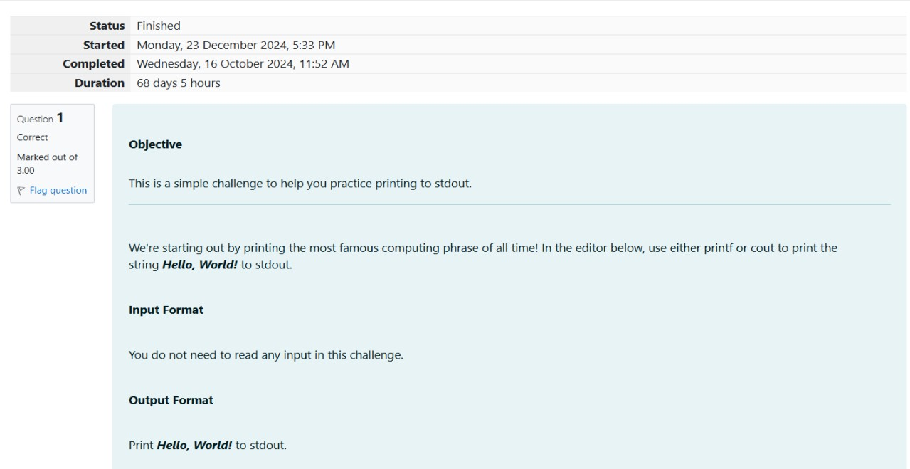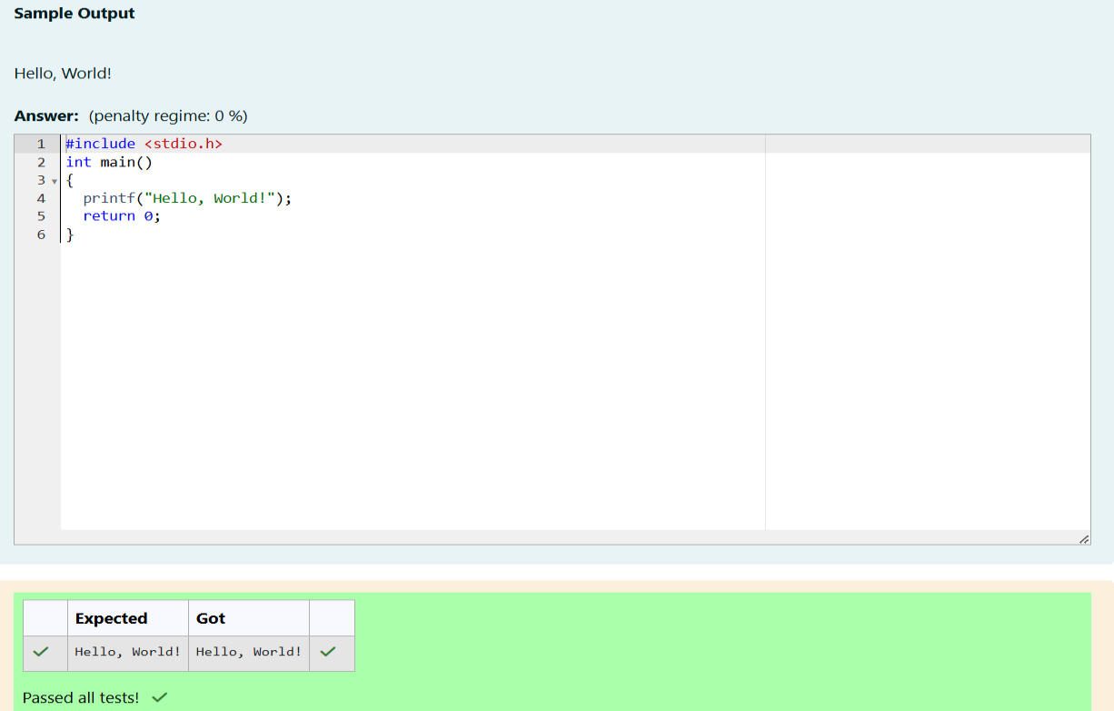NAME: RENUGADEVI S Q1)

Q2)

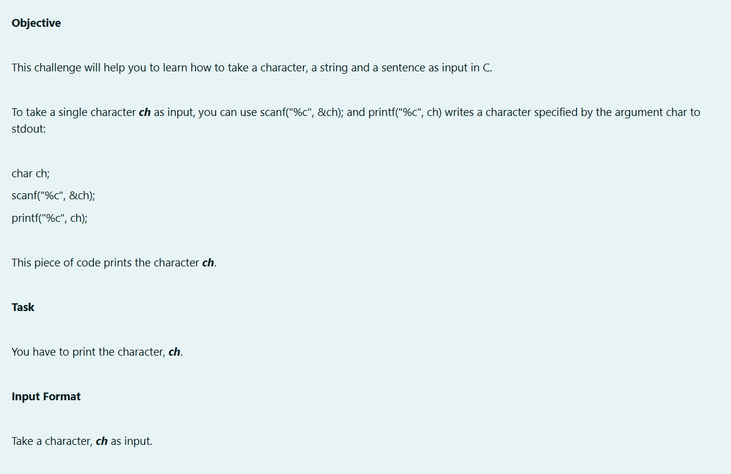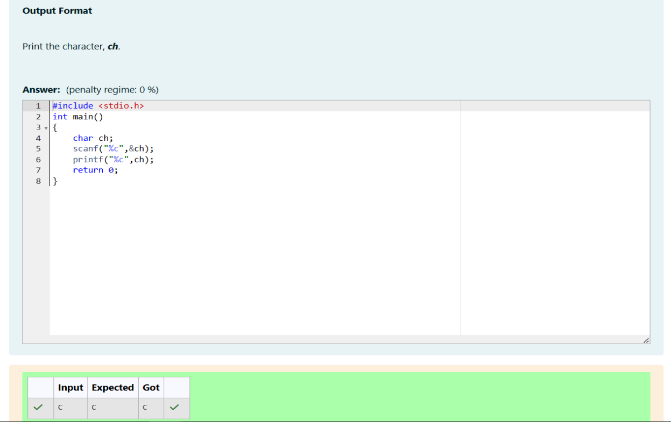

Q3)

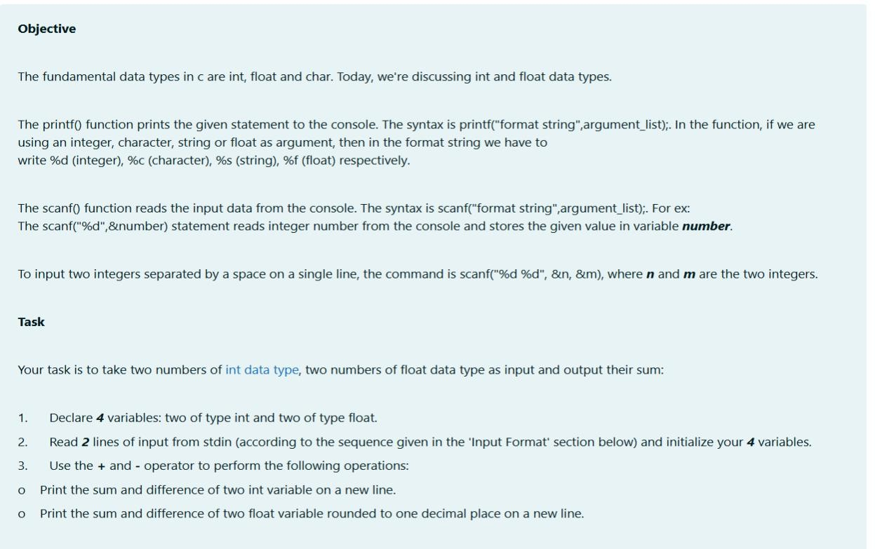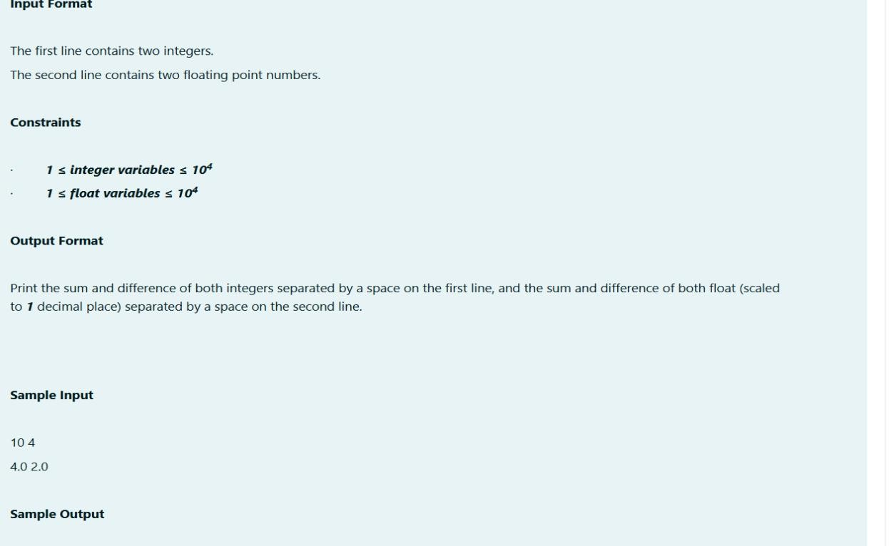

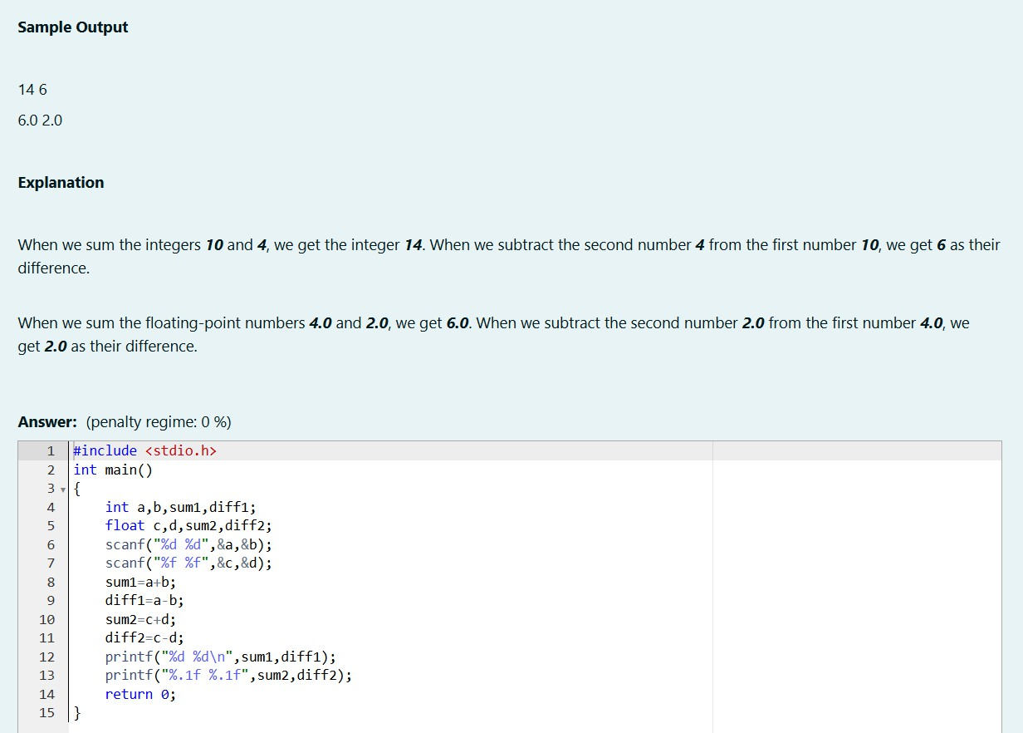

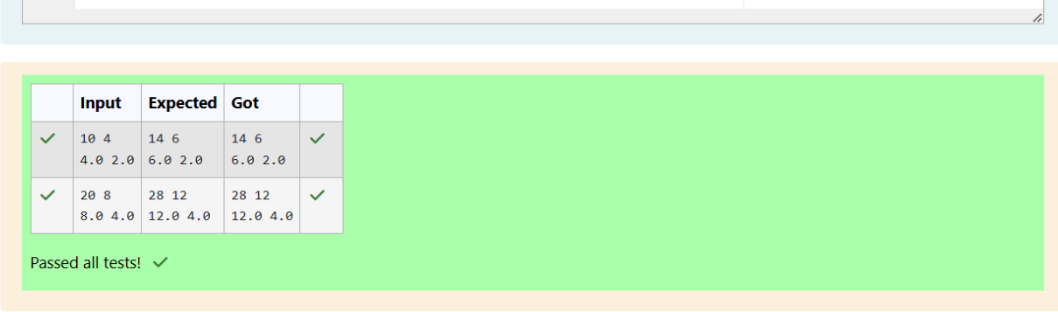

WEEK 01-02 PRACTICE SESSION CODING ROLL NO.:240901086

NAME: RENUGADEVI S Q1)

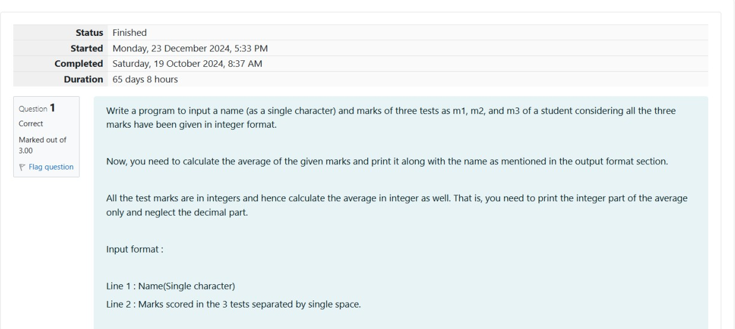

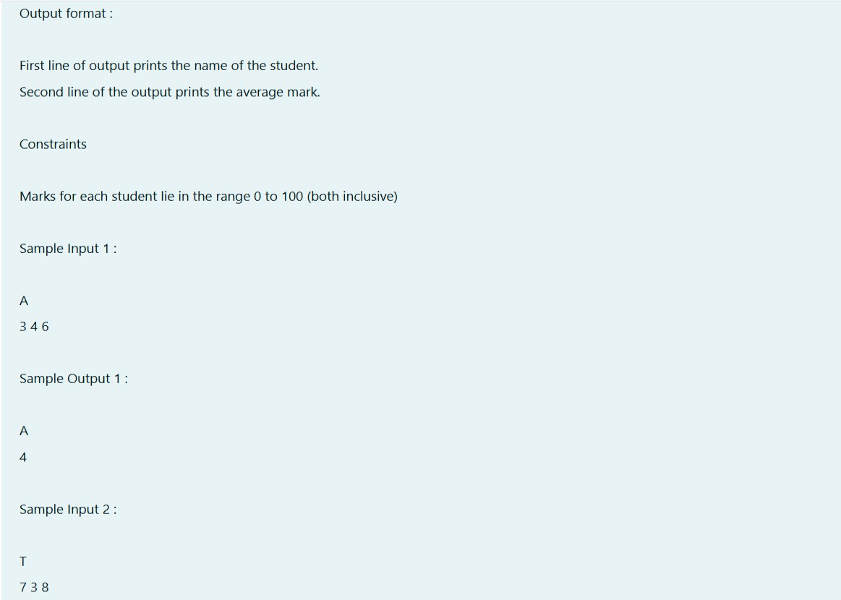

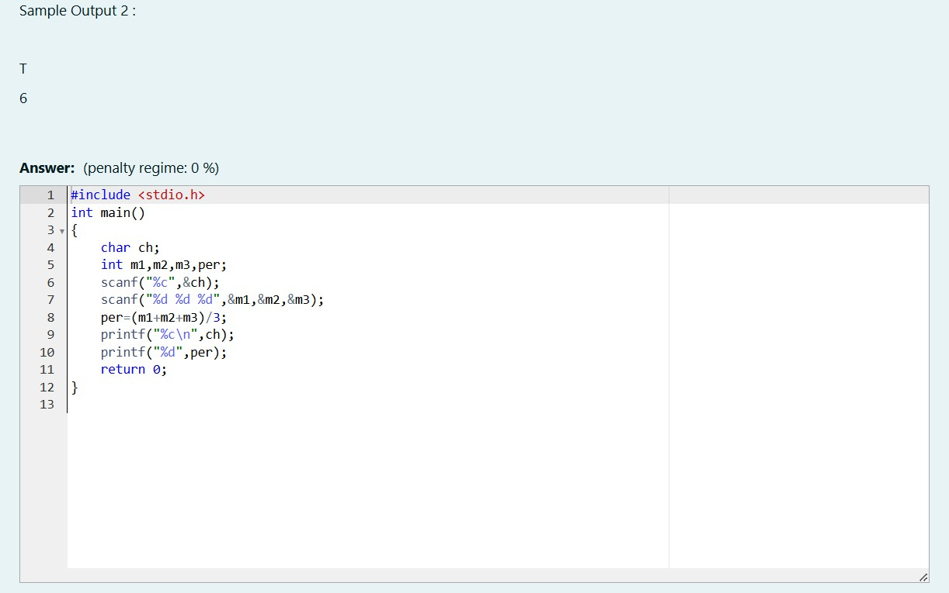

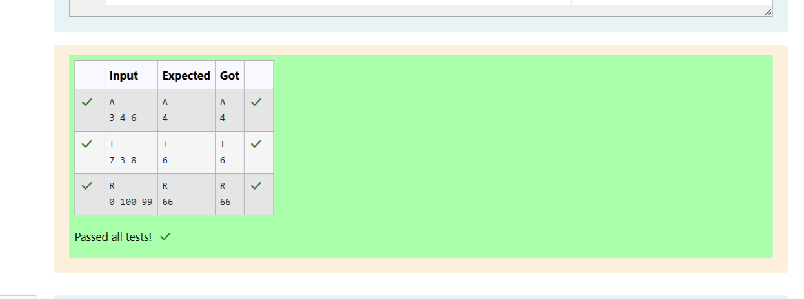

Q2)

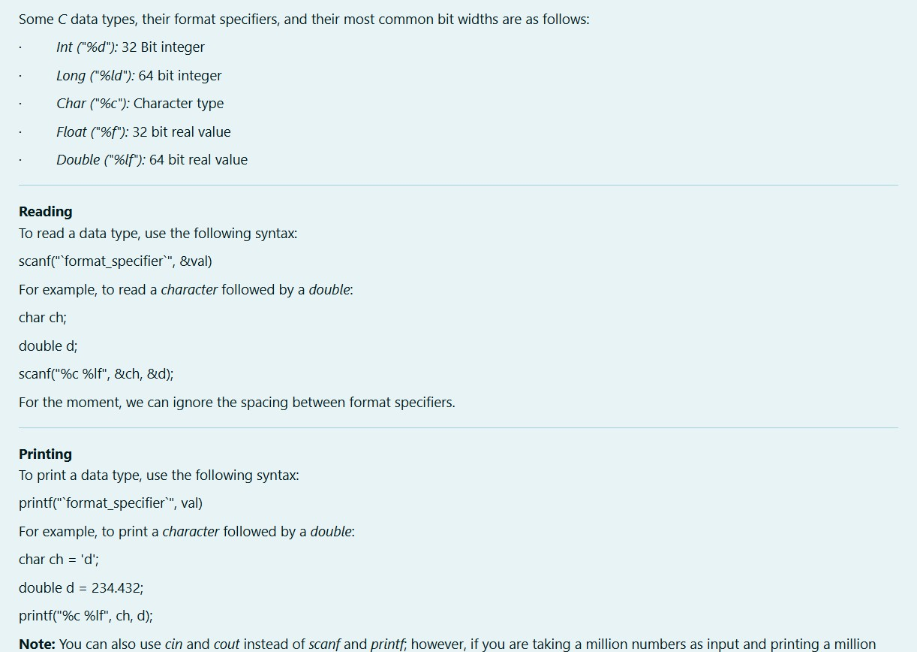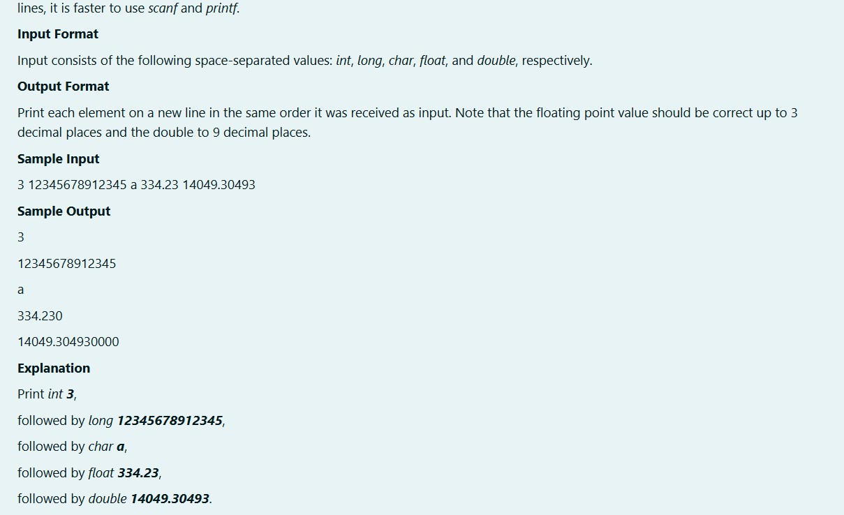

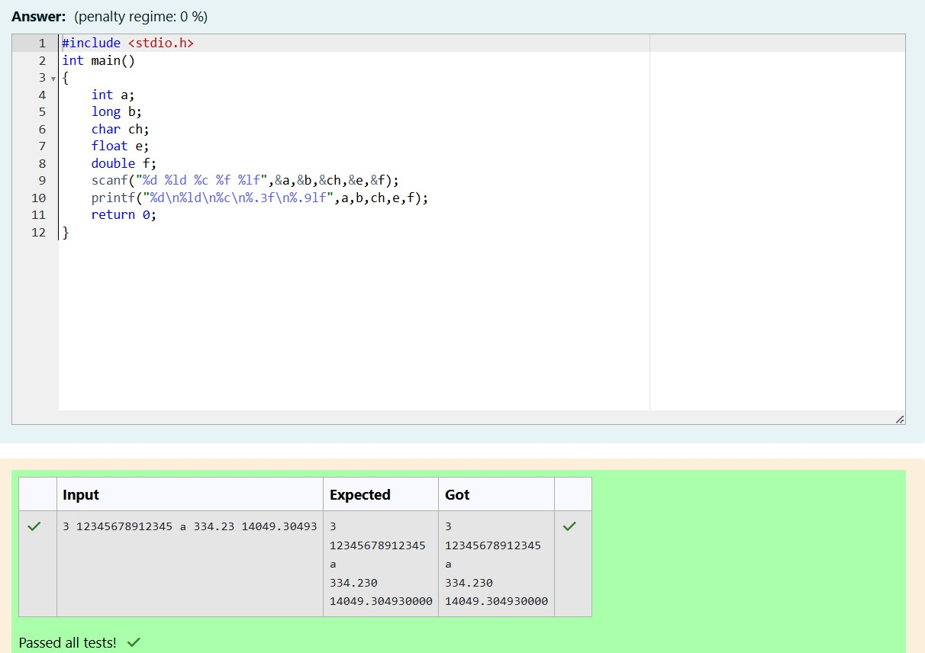

Q3)

